Steven Mahlman

Ruksana Bhuyan

Ian Arnold

Remy Jones II

Marek Novak

Assignment 4 - Creating a User Interface

CEN3722

Human Computer Interfaces

This is the public facing homepage of “Workout Mania” where users can see information regarding the website such as the about tab, features tab, pricing tab, team tab, and the blog tab. Users will be prompted to either login or register on the top right of the homepage. Returning users will toggle the “Login” action button while new users will toggle the “Register” (highlighted in orange) action button. Once toggled, the new user will be directed to the “Sign Up” page where they can enter in their information (pictured below).

From the “Workout Mania” home page, users can directly sign up/create an account. Users will fill out username, email address, password and confirm their passwords. Users will submit their information by toggling the “Register” (highlighted in orange) action button. Once complete, users will be directed to the main member homepage where they access workouts, workout histories, goals, and various account settings.

From the public facing homepage, users can access the member’s login page (pictured above). This page will prompt users to input their credentials that they used to create their account. Users will input their email that was used to create their account and the password associated with the account. Once logged in, the user will be directed to the member’s main homepage where they can track a workout, see their workout histories, set goals, and manage various settings of their accounts.

Once all users have either signed in or signed up, they will be directed to the main member homepage (pictured above). This page will give users access to track their workouts, view their workout histories, set their goals, and access various account settings to personalize their use of “Workout Mania”.

Users will be directed to the “Account Settings” page (pictured above) when they select their accounts on the main member’s homepage. On this page, members can change their daily, weekly, and monthly goals and also change basic settings such as workouts, activities, the home layout, and the appearance of the website. The appearance of the website can be adjusted between light or dark mode, or the appearance of the system. Users can toggle the “Workout Mania” (highlighted in orange) action button to be returned to the main member’s homepage.

From the member’s homepage (pictured above), users can toggle the “Track Your Workouts” action button to be directed to the “Your Workout” page (pictured below).

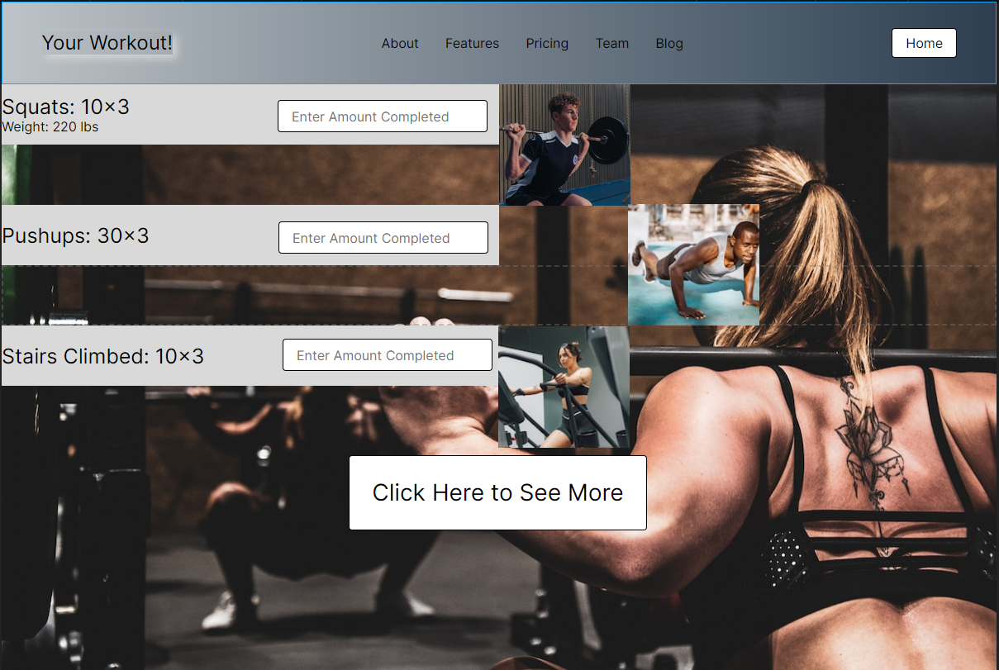

Once users' toggle “Track your workout” on the main member’s homepage, users will be directed to the “Your Workout” page (pictured above). Users will have the option to select an activity from the main menu or toggle the “Click here to see more” action button to access more workouts that are not listed on the page. Workouts will be recorded and saved to the account and users will have the ability to view previous workouts by toggling the “View Your Workout History” action button on the member’s homepage.